Assignment 1
Graphical User Interface Design
Weighting: 5%
Instructions: Complete the following exercises and submit in a Word document through Moodle (copy and paste the code into the document). The Word document should consist of (1) a header sheet with your name, student number, class and assignment number (2) the source code you have created (3) a screen shot of the final outputs.
Part 1: (35%)
Create and place the following GUI with buttons using layout management.
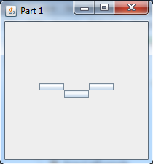
No text in the constructor allows for buttons with no text…..

Part 2: (35%)
Using the previous code (copy into a new class!) add a checkbox which starts on false. When the checkbox is selected, the buttons are coloured – red blue and green. When unselected, they turn lightGray.
Before: Clicked:
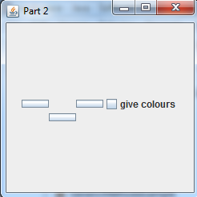
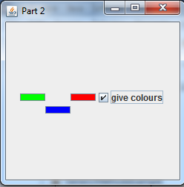

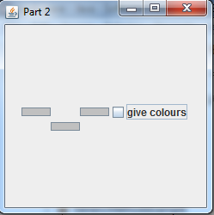
Unclicked:

Buttons move after the checkbox is added, don’t worry about fixing them!.

Part 3: (30%)
Create a House Class. Instance variables: number of bedrooms, number of bathrooms, surname of owners.
Overload constructors – one empty sets all details to null or 0, one which takes all information.
Getters and Setters, PrintDetails methods.
Create 2 House Objects using non-empty constructor. Create 1 House Object using empty constructor – use sets to fill details. Use print details to give the following output: (be careful of System.out.print() vs System.out.println()
